**Practical 7**

**AIM : Design a webpage to handle asynchronous requests using AJAX on**

a. Mouseover b. button click

**Q.1) Aim :Write an Ajax code to display a message saying “Hello,welcome to the world of ajax.”**

**Code:**

<html>

<head>

<title>Ajax at work</title>

<script language="javascript"> var XMLHttpRequestObject=false;

if(window.XMLHttpRequest)

{

XMLHttpRequestObject = new XMLHttpRequest();

}

else if(window.ActiveXObject)

{

XMLHttpRequestObject=new ActiveXObject("Microsoft.XMLHTTP");

}

function getData(dataSource, divID)

{

if(XMLHttpRequestObject)

{

var obj= document.getElementById(divID)

XMLHttpRequestObject.open("GET", dataSource);

XMLHttpRequestObject.onreadystatechange=function()

{

if (XMLHttpRequestObject.readyState==4 && XMLHttpRequestObject.status==200)

{

obj.innerHTML=XMLHttpRequestObject.responseText;

}

}

XMLHttpRequestObject.send(null);

}

}

</script>

</head>

<body>

<H1>Fetching data with Ajax</H1>

<form>

<input type="button" value = "Display Message" onclick="getData('hello.txt','targetDiv')">

</form>

<div id="targetDiv">

<p>The fetched data will go here</p></div>

</body>

</html>

Txt message:

Hello, welcome to the world of ajax.

**Output :**

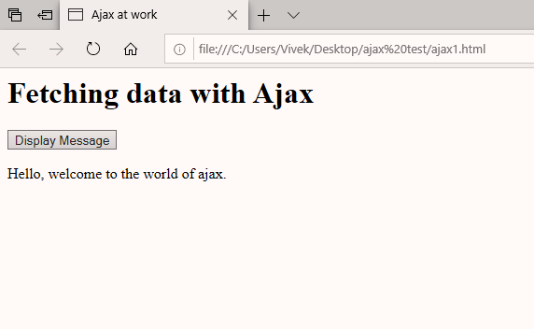

**Q.2) Aim : Write an Ajax code to displays the menu of the object when the cursor is pointing on it.**

**Code :**

<html>

<head>

<title>Ajax at work</title>

<script language="javascript"> var XMLHttpRequestObject=false;

if(window.XMLHttpRequest)

{

XMLHttpRequestObject = new XMLHttpRequest();

}

else if(window.ActiveXObject)

{

XMLHttpRequestObject=new ActiveXObject("Microsoft.XMLHTTP");

}

function getData(dataSource, divID)

{

if(XMLHttpRequestObject)

{

var obj= document.getElementById(divID); XMLHttpRequestObject.open("GET", dataSource);

XMLHttpRequestObject.onreadystatechange=function()

{

if (XMLHttpRequestObject.readyState==4 && XMLHttpRequestObject.status==200)

{

obj.innerHTML=XMLHttpRequestObject.responseText;

}

}

XMLHttpRequestObject.send(null);

}

}

</script>

</head>

<body>

<H1>Fetching data with Ajax</H1>

<form>

<img src="sandwich.jpg" onmouseover="getData('sandwich.txt','targetDiv')" height="200" width="200">

<img src="pizza.jpg" onmouseover="getData('pizza.txt','targetDiv')">

</form>

<div id="targetDiv">

<p>The fetched data will go here</p>

</div>

</body>

</html>

Sandwich txt message: 1)veg sandwich 2)Grilled sandwich 3)Masala Toast

Pizza txt message:

1. Cheese Pizza
2. Veg Loaded
3. Paneer onion